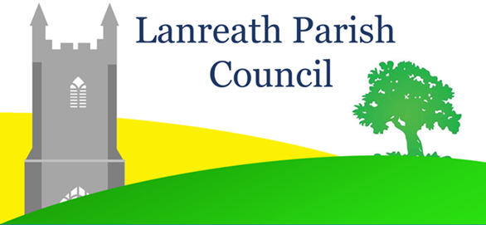
Lanreath Parish Council
Safeguarding Children and Vulnerable Adults Policy
Version Number | Date Proposed | Date Last Reviewed | Date Last Approved
1 | 11th April 2019 | 16th May 2023 | 16th May 2023

The Council recognises that it is the duty of everyone to protect children and vulnerable adults. The council does not directly organise any activities for children, young people or vulnerable adults, and has no direct contact with them through staff or Council members. However, the Council does work with other community groups that do have such contact, and recognises that it has a duty of care for children, young people and vulnerable adults. This is achieved by requiring that organisers of events are aware of safeguarding requirements and good practice and by maintaining a general overview of all activities taking place in Council property, or in the name of the Council.
Definitions:
Child or Young Person: anyone under the age of 18.
Vulnerable Adult: Anyone over 18 who is
- Unable to care for themselves
- Unable to protect themselves from harm.
- May be in need of community care services
Who Does This Policy Apply to?
This policy applies to anyone working for or on behalf of Lanreath Parish Council, whether in a paid, voluntary or commissioned capacity.
Promoting a Safe Environment.
In order to provide a safe environment for children, young people and vulnerable adults Lanreath Parish Council will ensure:
- That those working for the council in any capacity are aware of safeguarding policies, culture and expectations.
- That contact details are available of statutory agencies for advice and referral as follows:

- Multi Agency Referral Unit (MARU) for Children and Young People: 0300 1231 116

- Adult Safeguarding Access Team: 0300 1234 131 option 1.

- Adult Safeguarding Triage Team: 01872 326433

- That councillors have a duty to ensure the safety of children and vulnerable adults, but do not have a duty of investigation. Any concerns should be raised with the appropriate referral unit for advice/investigation.
Maintaining the Safety of Images of Children.
The Council will ensure that any images of children that are published by the Council, either on its website or in any literature which is published by them, are published with the consent of parents or legal guardians.
The Council will require that any organisations publishing images of children on the community section of the Lanreath Parish Council website also seek consent from parents or legal guardians.
The Council will ensure that children are not identified by name on its website.
Allegations Against Staff or Volunteers.
Councillors or volunteers should avoid placing themselves in a position where they could be vulnerable to accusations of inappropriate or abusive behaviour. This can be achieved by ensuring that there is another adult present at all times.
The Council should follow guidance published by the Cornwall and Isles of Scilly Safeguarding Children’s Partnership: Cornwall and the Isles of Scilly Safeguarding Children Partnership - Home page (ciossafeguarding.org.uk)
No action should be undertaken by the Council if concerns are raised before consulting the Local Authority Designated Officer (LADO): Tel. 01872 326536.
Whistle blowing.
The Council understands that children, young people and vulnerable adults cannot be expected to raise concerns on their own behalf. Council members therefore recognise that they have a duty to seek advice from the sources mentioned above if they have any concerns about any vulnerable individual's safety or wellbeing.
Identifying Causes for Concern.
Any behaviour, action or inaction towards a child, young person or vulnerable adult which affects their physical, emotional or psychological safety, wellbeing or development is considered abusive.
Abusers may be parents, carers, other family members, professionals or peers, and abuse can occur in any community or setting.
There are four recognised categories of abuse:
- Physical
- Emotional
- Sexual
- Neglect.
There is often more the one type of abuse occurring at the same time.
Councillors and volunteers also need to be aware that there are other threats to children, including Child Sexual Exploitation (CSE) and Female Genital Mutilation (FGM).
Ideally training in safeguarding should be undertaken but further training and information can be accessed from the following:
- Local Safeguarding Children Partnership;
- South West Child Protection Procedures:
- Cornwall Council Health and Social Care, Child Protection and Safeguarding:
- Cornwall Council, Health and Social Care, Safeguarding Adults:

Adoption
This policy was last reviewed and approved by Lanreath Parish Council on 16th May 2023

